
សាកលវិទ្យាល័យភូមិន្ទភ្នំពេញ
ROYAL UNIVERSITY OF PHNOM PENH

ប្រធានបទរបាយការណ៍ស្រាវជ្រាវ
Machine Learning-Based Diabetes Risk Prediction Using BRFSS and Cambodia STEPS Data

A Final Report
In Partial Fulfilment of the Requirement for the Degree of
Bachelor of Engineering in Data Science and Engineering

NHOR POVKETYA

June 2026
សាកលវិទ្យាល័យភូមិន្ទភ្នំពេញ
ROYAL UNIVERSITY OF PHNOM PENH

ប្រធានបទនិរបាយការណ៍ស្រាវជ្រាវ
Machine Learning-Based Diabetes Risk Prediction Using BRFSS and Cambodia STEPS Data

A Final Report
In Partial Fulfilment of the Requirement for the Degree of
Bachelor of Engineering in Data Science and Engineering

NHOR POVKETYA

Examination committee: Dr. Khim Chamroeun (Chairperson)
Dr. Mao Makara
Mr. Chap Chanpiseth

June 2026

Abstract in Khmer

ជំងឺទឹកនោមផ្អែម គឺជាបញ្ហាប្រឈមផ្នែកសុខភាពសាធារណៈដ៏ធំមួយនៅកម្ពុជា ដែលទាមទារឱ្យមានការពិនិត្យស្វែងរកហានិភ័យតាំងពីដំបូង ដើម្បីទប់ស្កាត់ផលវិបាកធ្ងន់ធ្ងរ។ ទោះជាយ៉ាងណា ប្រទេសកម្ពុជានៅខ្វះខាតឧបករណ៍ព្យាករណ៍ (Predictive Tools) ដោយសារទិន្នន័យសុខភាពក្នុងស្រុកនៅមានកម្រិតតិចតួច។ ដើម្បីដោះស្រាយបញ្ហានេះ ការសិក្សានេះបានបង្កើតប្រព័ន្ធ Explainable Machine Learning (ML) សម្រាប់ព្យាករណ៍ហានិភ័យជំងឺទឹកនោមផ្អែម ដោយប្រើបច្ចេកទេសផ្ទេរទិន្នន័យ (Cross-dataset transfer) ពីសំណុំទិន្នន័យសុខភាពសាធារណៈដ៏ធំរបស់អាមេរិកគឺ BRFSS ឆ្នាំ២០១៧ (សម្រាប់ធ្វើ Training និង Internal Validation) មកអនុវត្តលើគំរូប្រជាជនកម្ពុជា តាមរយៈសំណុំទិន្នន័យ Cambodia STEPS ដែលមានកំណត់ត្រាអាចប្រើប្រាស់បានចំនួន ៨៧៣ បន្ទាប់ពីការសម្អាតទិន្នន័យ និងការតម្រឹមលក្ខណៈពិសេស (សម្រាប់ធ្វើ Test Set)។ សំណុំទិន្នន័យទាំងពីរត្រូវបានតម្រឹមឱ្យនៅសល់លក្ខណៈសម្បត្តិរួមគ្នាចំនួន ១១ Features ដែលជាប្រភេទ Non-invasive (មិនរាតត្បាតរាងកាយ) រួមមានព័ត៌មានប្រជាសាស្ត្រ (Demographics) ស្ថានភាពសុខភាព និងទម្លាប់រស់នៅ។ នៅក្នុងដំណើរការរៀបចំទិន្នន័យ ទិន្នន័យ BRFSS ត្រូវបានបែងចែកជា Training Set ៨០% និង Validation Set ២០% តាមវិធីសាស្ត្រ Stratified Splitting ហើយបច្ចេកទេស SMOTETomek ត្រូវបានយកមកប្រើប្រាស់តែនៅលើ Training Set ប៉ុណ្ណោះ ដើម្បីដោះស្រាយបញ្ហាអតុល្យភាពទិន្នន័យ (Class Imbalance) ដោយរក្សាទុក Validation និង Test Set ឱ្យនៅដដែលដើម្បីជៀសវាងបញ្ហា Data Leakage។

នៅក្នុងការសិក្សានេះ ម៉ូដែល Machine Learning ចំនួន ៥ ត្រូវបានយកមកបណ្តុះបណ្តាល រួមមាន Logistic Regression, Random Forest, XGBoost, LightGBM, និង CatBoost។ ក្នុងនោះ ម៉ូដែលដែលខ្លាំងជាងគេចំនួន ៣ គឺ XGBoost, Logistic Regression, និង CatBoost ត្រូវបានរួមបញ្ចូលគ្នាជាម៉ូដែលរួមមួយហៅថា Soft Voting Ensemble។ យើងបានជ្រើសរើសយកកម្រិតចាត់ថ្នាក់ (Classification Threshold) ស្មើនឹង 0.43 ដោយផ្អែកលើការផ្ទៀងផ្ទាត់ F1-score និងលក្ខខណ្ឌតម្រូវឱ្យម៉ូដែលដឹងពីអ្នកជំងឺពិតប្រាកដយ៉ាងហោចណាស់ ៧០% (Recall >= 70%)។ ជាលទ្ធផលនៅលើសំណុំទិន្នន័យតេស្តឯករាជ្យ Cambodia STEPS ម៉ូដែល Soft Voting Ensemble នេះសម្រេចបានអត្រារកឃើញអ្នកជំងឺពិត (Recall) 76.23%, ភាពត្រឹមត្រូវនៃការព្យាករណ៍ (Precision) 20.58%, ភាពត្រឹមត្រូវសរុប (Accuracy) 55.56%, និងទទួលបាន F1-score 32.40%។ លទ្ធផលទាំងនេះបង្ហាញថា ម៉ូដែលដែលបានស្នើឡើងមានសមត្ថភាពខ្ពស់ក្នុងការស្វែងរកករណីជំងឺទឹកនោមផ្អែមភាគច្រើននៅក្នុងប្រជាជនកម្ពុជា ប៉ុន្តែវាក៏បង្កើតលទ្ធផលវិជ្ជមានក្លែងក្លាយច្រើនផងដែរ (High False Positives) ដែលនេះបណ្តាលមកពីភាពខុសគ្នានៃទម្រង់ប្រជាជន (Population Characteristics) រវាងសហរដ្ឋអាមេរិក និងកម្ពុជា។

ដើម្បីជួយឱ្យម៉ូដែលនេះអាចពន្យល់ហេតុផលបាន ប្រព័ន្ធ SHAP ត្រូវបានយកមកប្រើប្រាស់ជាមួយ XGBoost ក្នុងនាមជា Tree-based Proxy Model ដើម្បីបង្ហាញពីកត្តាហានិភ័យទាំងកម្រិតរួម (Global) និងកម្រិតបុគ្គល (Patient-level) ដែលក្នុងនោះកត្តាហានិភ័យចម្បងៗរួមមាន BMI, ជំងឺលើសឈាម (High Blood Pressure), កូលេស្តេរ៉ុលខ្ពស់ (High Cholesterol), អាយុ, និងសកម្មភាពរាងកាយ (Physical Activity)។ ប្រព័ន្ធចុងក្រោយនេះត្រូវបានដាក់ឱ្យដំណើរការនៅលើផ្ទាំងកម្មវិធី Streamlit Web Dashboard ដែលអាចបង្ហាញកម្រិតហានិភ័យ លទ្ធផលពន្យល់ពី SHAP និងផ្តល់ការណែនាំអំពីការកែប្រែរបៀបរស់នៅ (Lifestyle Recommendations) ដែលអាចអនុវត្តបាន។ ជាសន្និដ្ឋាន ការសិក្សានេះបង្ហាញថា Explainable AI អាចជួយគាំទ្រដល់ការពិនិត្យហានិភ័យជំងឺទឹកនោមផ្អែមតាំងពីដំបូងបានយ៉ាងល្អ ប៉ុន្តែវាគួរតែត្រូវបានប្រើប្រាស់ត្រឹមជាឧបករណ៍ជួយពិនិត្យស្រាវជ្រាវបឋម (Screening Support Tool) ប៉ុណ្ណោះ មិនមែនជាប្រព័ន្ធវិនិច្ឆ័យរោគផ្លូវការ (Medical Diagnosis System) ជំនួសគ្រូពេទ្យឡើយ។

ពាក្យគន្លឹះ Diabetes Risk Prediction, Explainable AI, Machine Learning, SHAP, BRFSS, Cambodia STEPS, Screening Support Tool.

Abstract in English

Diabetes mellitus is a growing public health challenge, and early screening is important for reducing late complications. In Cambodia, diabetes risk prediction tools are still limited because local labelled health survey data are small in scale. This study addresses this problem by developing an explainable machine learning framework for diabetes risk prediction using cross-dataset transfer from a large public health dataset to a Cambodian population sample.
The Behavioral Risk Factor Surveillance System (BRFSS) 2017 dataset was used for model training and internal validation, while the Cambodia STEPS dataset, containing 873 usable records after preprocessing and feature alignment, was reserved exclusively as the final independent test set. Both datasets were aligned into 11 shared non-invasive features, including demographic, health-status, and lifestyle variables. The BRFSS data were split into 80% training and 20% validation using stratified sampling. SMOTETomek was applied only to the training set to handle class imbalance, while the validation and test sets were kept untouched to avoid data leakage.
Five machine learning models were trained: Logistic Regression, Random Forest, XGBoost, LightGBM, and CatBoost. The three strongest models, XGBoost, Logistic Regression, and CatBoost, were combined into a Soft Voting ensemble. The final model and classification threshold were selected using validation F1-score while requiring diabetes recall of at least 70%. The selected threshold was 0.43. On the Cambodia STEPS independent test set, the final Soft Voting ensemble achieved 76.23% recall, 20.58% precision, 55.56% accuracy, and 32.40% F1-score.
The results show that the proposed model can identify most diabetes cases in the Cambodian test population, although it also produces many false positives because of cross-population differences between the United States and Cambodia. SHAP was used with XGBoost as a tree-based proxy model to explain global and patient-level predictions. The most important risk factors included BMI, high blood pressure, high cholesterol, age, and physical activity. The final system was presented through a Streamlit dashboard that provides risk tiers, explanation results, and actionable lifestyle recommendations. This study shows that explainable AI can support early diabetes risk screening, but it should be used as a screening support tool rather than a medical diagnosis system.
Keywords: Diabetes Risk Prediction, Explainable AI, Machine Learning, SHAP, BRFSS, Cambodia STEPS, Screening Support Tool.

SUPERVISOR’S RESEARCH SUPERVISION STATEMENT

TO WHOM IT MAY CONCERN

Name of program: Bachelor of Engineering in Data Science and Engineering
Name of candidate: Nhor Povketya

Title of research report: Explainable AI for Diabetes Risk Prediction and Actionable Insights

This is to certify that the research carried out for the above titled Bachelor’s research report was completed by the above-named candidate under my direct supervision. This thesis material has not been used for any other degree. I played the following part in the preparation of this research report: ………………………………………………………….
…………………………………………………………...................................................................................................................................................................................................................................................................................................................................................................................................................................................

Supervisor's name: Dr. Khim Chamroeun

Supervisor’s signature:…………………….

Date……………………………………………

CANDIDATE’S STATEMENT

TO WHOM IT MAY CONCERN

This is to certify that the research report that I, Nhor Povketya, hereby present entitled: Explainable AI for Diabetes Risk Prediction and Actionable Insights for the degree of Bachelor of Engineering at the Royal University of Phnom Penh is entirely my own work and, furthermore, that it has not been used to fulfil the requirements of any other qualification in whole or in part, at this or any other University or equivalent institution.

No reference to, or quotation from, this document may be made without the written approval of the author.

Signed by Nhor Povketya: …………………………

Date: ……………………………………………….

Sign by Supervisor: Dr. Khim Chamroeun

Supervisor’s signature: ………………………...…

Date…………………………………………….…

Acknowledgements

With sincere appreciation, I would like to express my deepest gratitude to my supervisor, Dr. Khim Chamroeun, for his valuable guidance, patience, encouragement, and constructive feedback throughout the completion of this research. His knowledge and advice have greatly helped me improve the quality of this study and shaped the direction of my work in machine learning, explainable artificial intelligence, and public health research.
I would also like to sincerely thank the Royal University of Phnom Penh, especially the Department of Data Science and Engineering, for providing me with the academic foundation, learning environment, and support needed to complete this final year research project. The knowledge and skills I have gained throughout my studies have been very important in carrying out this work.
I am also grateful to the Centers for Disease Control and Prevention (CDC) for making the BRFSS dataset publicly available. I would like to extend my appreciation to the World Health Organization (WHO) and the Ministry of Health of Cambodia for providing access to the Cambodia STEPS survey data for academic research. These data sources were essential for conducting this study.

Finally, I would like to give my deepest thanks to my family and friends for their love, encouragement, and support throughout this journey. Their understanding and motivation helped me continue working even during difficult times.

Table of Contents
Abstract in Khmer iii
Abstract in English v
SUPERVISOR’S RESEARCH SUPERVISION STATEMENT vi
CANDIDATE’S STATEMENT vii
Acknowledgements viii
LIST OF TABLES xiii
LIST OF FIGURES xiv
LIST OF ABBREVIATIONS xv
CHAPTER 1 INTRODUCTION 1
1.1 Background to the Study 1
1.2 Problem Statement 2
1.3 Aim and Objectives 2
1.4 Rationale of the Study 3
1.5 Limitation and Scope 3
1.6 Structure of the Study 3
CHAPTER 2 LITERATURE REVIEW 6
2.1 Diabetes Risk Prediction Using Survey Data 6
2.2 Machine Learning Models for Diabetes Prediction 6
2.3 Class Imbalance and Resampling 6
2.4 The Importance of Recall in Screening 7
2.5 Explainable AI and SHAP in Healthcare 7
2.6 Cross-Population Generalisation 7
2.7 Research Gap and Contribution 8
CHAPTER 3 METHODOLOGY AND TOOLS 9
3.1 Research Design 9
3.2 Tools and Technologies Used 9
3.2.1 Python and Visual Studio Code 10
3.2.2 pandas, NumPy, and Matplotlib 10
3.2.3 scikit-learn 10
3.2.4 XGBoost, LightGBM, and CatBoost 10
3.2.5 imbalanced-learn (SMOTETomek) 10
3.2.6 SHAP 10
3.2.7 Streamlit and the Gemini API 10
3.3 Data Sources 11
3.3.1 BRFSS 2017 (Training and Validation) 11
3.3.2 Cambodia STEPS (Independent Test) 11
3.4 Data Preparation and Feature Alignment 11
3.5 Feature Engineering and Imbalance Handling 12
3.5.1 Standardisation 12
3.5.2 SMOTETomek and Data Leakage 12
3.6 Models Used 12
3.6.1 Logistic Regression 12
3.6.2 Random Forest 13
3.6.3 XGBoost 13
3.6.4 LightGBM 13
3.6.5 CatBoost 13
3.7 Soft Voting Ensemble 13
3.8 Threshold Tuning 13
3.9 Evaluation Metrics 14
3.9.1 Confusion Matrix 14
3.9.2 Accuracy, Precision, Recall, and F1-Score 14
3.9.3 ROC Curve and AUC 15
3.10 Explainability Method 15
CHAPTER 4 RESULTS 17
4.1 Experimental Setup 17
4.2 Data Distribution 17
4.3 Data Splits 17
4.4 Class Balancing with SMOTETomek 18
4.5 Validation Results of Individual Models 19
4.6 Final Model and Threshold Selection 20
4.7 Risk Tiers and the Classification Threshold 21
4.8 Independent Test on Cambodia STEPS 22
4.9 Validation vs Test Comparison 23
4.10 Explainability Results 24
4.11 Patient Dashboard and Actionable Insights 26
CHAPTER 5 DISCUSSION 28
5.1 Overview 28
5.2 Effectiveness of the Models 28
5.3 The Cross-Population Gap 28
5.4 Value of Explainability and the Dashboard 29
5.5 Challenges and Findings 29
CHAPTER 6 CONCLUSION 30
6.1 Summary of Findings 30
6.2 Future Work 30
REFERENCES 32
APPENDICES 34
Appendix A: Deployed Application 34
Appendix B: Source Code and Notebooks 34
Appendix C: Reproducibility 34

LIST OF TABLES

Table 1: Aligned feature set common to BRFSS and STEPS (11 features). 11
Table 2: Class distribution per data split. Cambodia STEPS is used only for the final test. 18
Table 3: Training-set class counts before and after SMOTETomek (validation and test untouched). 18
Table 4: Individual model performance on the BRFSS 2017 validation set (threshold 0.50). 19
Table 5: Validation performance of the selected Soft Voting ensemble at threshold 0.43. 20
Table 6: Risk-tier distribution of the Cambodia STEPS respondents under the Soft Voting model. 22
Table 7: Independent test results on Cambodia STEPS (Soft Voting ensemble, threshold 0.43). 22
Table 8: Validation versus independent-test results for the Soft Voting ensemble. 24

LIST OF FIGURES

Figure 1: Research design and pipeline workflow, from data loading and feature alignment to training, ensemble selection, threshold tuning, independent testing, explainability, and the dashboard. 9
Figure 2: The structure of a confusion matrix, showing true positives, true negatives, false positives, and false negatives. 14
Figure 3: Illustration of an ROC curve and the area under the curve (AUC). 15
Figure 4: Class distribution of BRFSS 2017 (training source) and Cambodia STEPS (independent test). 17
Figure 5: Class distribution across the training, validation, and test splits (log scale, because BRFSS is much larger than STEPS). 18
Figure 6: BRFSS 2017 training set before and after SMOTETomek balancing. 19
Figure 7: Comparison of the five models on the validation set (threshold 0.50). 20
Figure 8: Threshold tuning result on the validation set, showing how recall, precision, F1-score, and accuracy change with the threshold, with the chosen threshold of 0.43 marked. 21
Figure 9: Risk-tier distribution for the Cambodia STEPS test set. 22
Figure 10: Confusion matrix on the Cambodia STEPS test set (Soft Voting, threshold 0.43). 23
Figure 11: Validation versus Cambodia STEPS test results for the Soft Voting ensemble. 24
Figure 12: SHAP global feature importance (mean absolute SHAP value) on the Cambodia STEPS test set, using XGBoost as the tree-based proxy model. 25
Figure 13: SHAP local explanation for a single Cambodia STEPS patient, showing which features increased or decreased the predicted risk. 25
Figure 14: Distribution of predicted probabilities on Cambodia STEPS, separated by true class, with the 30% and 70% tier cut-offs marked. 26
Figure 15: Patient dashboard from the deployed application, showing the risk gauge, the main SHAP reasons, the group contributions, and the lifestyle advice. 27

LIST OF ABBREVIATIONS

AUC Area Under the (ROC) Curve
BMI Body Mass Index
BRFSS Behavioral Risk Factor Surveillance System
CatBoost Categorical Boosting
CDC Centers for Disease Control and Prevention
F1 F1-Score (harmonic mean of precision and recall)
LightGBM Light Gradient Boosting Machine
LIME Local Interpretable Model-agnostic Explanations
LR Logistic Regression
ML Machine Learning
NCD Non-Communicable Disease
RF Random Forest
ROC Receiver Operating Characteristic
SHAP SHapley Additive exPlanations
SMOTE Synthetic Minority Oversampling Technique
SMOTETomek SMOTE combined with Tomek-links cleaning
STEPS WHO STEPwise Approach to NCD Risk-Factor Surveillance
WHO World Health Organization
XAI Explainable Artificial Intelligence
XGBoost Extreme Gradient Boosting

CHAPTER 1
INTRODUCTION

1.1 Background to the Study
Diabetes is one of the most common chronic diseases in the world today. It happens when the body cannot control the level of sugar in the blood, and over time it can damage the heart, blood vessels, kidneys, eyes, and nerves. Most cases are type 2 diabetes, which is closely linked to age, body weight, diet, physical activity, and other lifestyle factors. Many of these factors can be changed, so people who are found to be at risk early can take action before the disease becomes serious.
In Cambodia, the number of people with diabetes has been rising as the country becomes more urban and diets change. National surveys carried out under the WHO STEPwise approach (STEPS) have shown that a large share of Cambodian adults have diabetes or are at risk, and that many of them do not know it. Because screening services are limited, people often discover the disease only after complications have already started, when treatment is harder and more expensive.
Finding people at high risk early is therefore important for public health. If we can flag people who are likely to have diabetes using simple and low-cost information such as age, body mass index, blood pressure history, and lifestyle habits, those people can be sent for proper testing and given advice in time. Machine learning is a useful tool for this, because it can learn the relationship between many risk factors and the disease, and it can give a risk estimate quickly.
However, two problems make this difficult in Cambodia. The first is data. Large, well-labelled diabetes datasets are common in rich countries but rare in Cambodia, where collecting confirmed labels at a large scale is costly. The second is trust. A model that only outputs a number, without explaining why, is a black box, and it is hard for health workers or patients to trust a result they cannot understand. This study deals with both problems by testing whether a model trained on foreign data can work on Cambodian data, and by making the predictions explainable.

1.2 Problem Statement
The main problem in this study is how to identify people at risk of type 2 diabetes in Cambodia in an early, low-cost, and trustworthy way, when local labelled data are limited. Collecting a large Cambodian dataset would be ideal, but it is expensive and slow, and the result would still be small compared with the data available internationally.
One option is to use a large foreign dataset, the United States BRFSS survey, which has hundreds of thousands of labelled records, and to test the model on the Cambodian population through the STEPS survey. This raises a question that is not well answered in the local context: how well does a diabetes model trained on one population work on a different population, with different diets, body types, and survey methods?
There is also the problem of class imbalance. People with diabetes are the minority in both surveys, so a model that simply predicts “no diabetes” for everyone would look accurate but would be useless. In screening, a false negative, which means telling a person at risk that they are fine, is more harmful than a false positive, which only leads to an extra test. For this reason, the model in this study is built to give high recall rather than just high accuracy, and it is designed to be explainable so that its results can be trusted and acted on.

1.3 Aim and Objectives
The aim of this study is to build and honestly evaluate an explainable machine learning pipeline that screens for diabetes risk in Cambodia by transferring a model trained on a large foreign survey, while keeping recall high and the results easy to understand.
The specific objectives are:
• Objective 1: align the BRFSS (United States) and STEPS (Cambodia) surveys into a shared set of common, low-cost risk factors
• Objective 2: build a clear preprocessing pipeline with scaling and class-imbalance handling applied only to the training data
• Objective 3: train and compare five machine learning models, namely Logistic Regression, Random Forest, XGBoost, LightGBM, and CatBoost, and combine the best three models into a Soft Voting ensemble
• Objective 4: select the final model and decision threshold using validation F1-score while keeping recall high, instead of using accuracy alone
• Objective 5: test the final model once on the Cambodia STEPS data, which is never used during training or selection, to measure honest cross-population performance
• Objective 6: explain the model with SHAP, both overall and for individual patients, and present the results in a simple dashboard with actionable lifestyle insights.

1.4 Rationale of the Study
There are three main reasons for this work. First, the number of undiagnosed diabetes cases in Cambodia is large and growing, and the cost of late diagnosis, in terms of complications such as kidney failure, blindness, and heart disease, is high. A screening tool that uses only simple information could help raise awareness beyond the limited number of clinics.
Second, the shortage of local labelled data will not be solved quickly, so it is worth finding out now, in an honest way, how far a transfer learning approach can go using free international data. A clear benchmark, including its weaknesses, is more useful than an over-optimistic claim of high accuracy. For this reason, this study reports its weaker numbers together with its strong recall.
Third, any tool used in health care needs to be trusted. Explainability methods such as SHAP can show which factors increase or decrease a person’s risk. Building explainability into the pipeline from the start, rather than adding it at the end, is what makes the difference between a research experiment and a tool that a health worker or patient could actually use.

1.5 Limitation and Scope
This study focuses on non-invasive, survey-based screening for type 2 diabetes risk. It does not aim to provide a medical diagnosis. A confirmed diagnosis of diabetes requires clinical laboratory tests such as fasting blood glucose, oral glucose tolerance test, or HbA1c. Therefore, the output of this system should be understood as a risk prediction result that can support early awareness and follow-up testing, not as a final medical decision.
The scope of this study is limited to machine learning models trained and validated on the BRFSS 2017 dataset and independently tested on the Cambodia STEPS dataset. The model uses only eleven shared features that could be aligned between the two surveys: Sex, Age, Education, HighBP, HighChol, BMI, Smoker, PhysActivity, Fruits, Veggies, and HvyAlcoholConsump. These features were selected because they are common to both datasets, non-invasive, and suitable for low-cost screening.
The main limitation of this study is the difference between the training and testing populations. BRFSS is a United States survey, while STEPS represents a Cambodian population. These two populations may differ in diet, lifestyle, body composition, healthcare access, disease awareness, and survey-question design. Because of this cross-population difference, the model may not generalize perfectly from BRFSS to Cambodia STEPS.
Another limitation is the small size of the Cambodia STEPS test set, which contains 873 usable records after data preprocessing and feature alignment. Although it is useful as an independent external test set, a larger Cambodian dataset would provide a more reliable evaluation. In addition, only eleven common features were used, so some useful diabetes risk factors, such as waist circumference, detailed diet information, family history, laboratory measurements, and medication history, were not included in the final model.
Because of these limitations, the results should be interpreted as an honest benchmark for cross-population diabetes risk screening, not as the best possible performance of a fully local Cambodian diabetes model. The system is useful for early screening, explainability, and awareness, but it should be improved in the future using larger, locally collected, clinically confirmed Cambodian data.

1.6 Structure of the Study
This report has six chapters. Chapter 1 has introduced the background, the problem, the aim and objectives, the rationale, and the scope.
Chapter 2 reviews related work on diabetes risk prediction with survey data, machine learning models, class imbalance, the importance of recall, explainable AI, and the cross-population gap, and then states the research gap.
Chapter 3 explains the methodology and tools, including the research design, the software used, the BRFSS and STEPS data, feature alignment, preprocessing, the models and the Soft Voting ensemble, threshold tuning, the evaluation metrics, and the explainability method.
Chapter 4 presents the results, including the data distributions, the validation comparison, the final model and threshold selection, the independent Cambodia STEPS test, the explainability results, and the risk tiers.
Chapter 5 discusses what the results mean, and Chapter 6 gives the conclusion and future work. References and appendices are at the end.

CHAPTER 2
LITERATURE REVIEW

2.1 Diabetes Risk Prediction Using Survey Data
Predicting diabetes risk from routine information has been studied for many years. Early methods used simple risk scores that added the weights of a few factors such as age, body mass index, and blood pressure. These scores are easy to use and transparent, but their fixed form does not capture complex relationships between factors, and they may not work well on populations that are different from the one used to build them.
Large health surveys have made it possible to build data-driven models instead. The Behavioral Risk Factor Surveillance System (BRFSS), run by the United States CDC, is one of the most widely used sources. It is useful for machine learning because it contains many behavioral, demographic, and health-status variables, such as smoking, physical activity, diet, education, age, blood pressure, and cholesterol, collected from hundreds of thousands of people. Xie et al. [1] used BRFSS data to build machine learning models for type 2 diabetes and showed that such survey data can support useful risk prediction, while also pointing out the importance of sensitivity (recall) for screening, because the goal is to catch as many true cases as possible.

2.2 Machine Learning Models for Diabetes Prediction
Many studies have compared machine learning models for diabetes prediction. Logistic Regression is commonly used as a simple and easy-to-explain baseline model. Tree-based models such as Random Forest and gradient boosting methods such as XGBoost, LightGBM, and CatBoost are also widely used for tabular health data because they can capture non-linear relationships between risk factors and diabetes outcomes. Recent reviews on diabetes prediction show that ensemble and boosting methods often perform well compared with single traditional models, especially when working with structured health survey data [3], [4]. These findings support the choice in this study to test Logistic Regression, Random Forest, XGBoost, LightGBM, and CatBoost, and to combine the strongest models into a Soft Voting ensemble.

2.3 Class Imbalance and Resampling
Diabetes datasets are usually imbalanced, because people with diabetes are the minority. If this is ignored, a model can become biased toward the majority class and miss many real cases. To deal with this, studies often use resampling methods such as SMOTE, which creates synthetic minority examples, or SMOTETomek, which adds SMOTE oversampling and then removes confusing borderline points. Khokhar et al. [2] combine SMOTE-type resampling with ensemble learning and explainable AI for diabetes prediction, which is close to the approach used in this study. An important rule, followed here, is that resampling must be applied only to the training data, so that the validation and test results are not affected by synthetic data.

2.4 The Importance of Recall in Screening
In diabetes screening, recall (also called sensitivity) is especially important. Recall measures how many of the real diabetes cases the model is able to find. A false negative, where a person who really has diabetes is told they are fine, is more dangerous than a false positive, where a healthy person is asked to do an extra test. For this reason, several studies, including Xie et al. [1], highlight recall as a key metric for screening, rather than focusing only on accuracy. This study follows the same idea by choosing the final model and threshold based on a recall requirement.

2.5 Explainable AI and SHAP in Healthcare
As models become more complex, they also become harder to understand, which is a problem in healthcare where decisions affect people. Explainable AI (XAI) tries to solve this. SHAP (SHapley Additive exPlanations) is one of the most popular methods. It gives each feature a value that shows how much it pushed a prediction up or down, both overall and for a single patient. LIME is another method that explains single predictions using a simple local model. Khokhar et al. [2], in their work on transparent and accurate diabetes prediction, show that combining machine learning with SHAP makes models more transparent and easier to trust. Their systematic review [3] also reports that explainability is becoming an important part of AI for diabetes prediction, alongside datasets, algorithms, and evaluation metrics. This supports the use of SHAP in this study.

2.6 Cross-Population Generalization
Most diabetes prediction studies train and test their models on the same population, usually with a random split of one dataset. This measures how well the model works on data similar to the training data, but it does not show how well the model works on a different population. Li et al. [4] discuss the performance of diabetes risk prediction models and the need for external validation, which means testing a model on data from a different source. When a model is used on a new population, it faces “domain shift”, where the relationship between the features and the disease is different. For example, the link between body mass index and diabetes risk is known to differ between Western and Asian populations. Studies that honestly test cross-population transfer, especially into low-resource settings such as Cambodia, are still rare.

2.7 Research Gap and Contribution
From this review, three gaps stand out. First, most studies test the same population and do not measure transfer to a new one. Second, most work is based in high-income countries, with little focus on low-resource settings such as Cambodia. Third, even though explainability is now discussed often, many applied studies still report only accuracy-type metrics and do not include patient-level explanations or a deployed tool.
This study addresses these gaps. It trains a model on BRFSS 2017 and tests it once, independently, on Cambodia STEPS, to measure honest cross-population performance. It uses a recall-focused selection rule that fits the needs of screening. And it uses SHAP to explain the model and presents the results in a simple dashboard with risk tiers and lifestyle advice. In this way, the study tests whether a model trained on BRFSS 2017 can generalize to Cambodia STEPS and uses explainability to support the interpretation of the results.

CHAPTER 3
METHODOLOGY AND TOOLS

3.1 Research Design
This study follows a clear, repeatable pipeline that goes from raw survey data to an explainable screening tool. The key design choice is to keep the training population, and the final test population separate. The model is trained and validated only on the United States BRFSS 2017 survey, and is then tested once on the independent Cambodia STEPS dataset. This design measures how well the model transfers to a new population, instead of only measuring performance on data similar to the training data.
The main steps, shown in Figure 1, are: load the two surveys; align them into eleven common features; split the BRFSS data into training and validation sets; scale the features and balance the training data with SMOTETomek; train five models; choose the three best on validation and combine them into a Soft Voting ensemble; select the final model and threshold using validation F1-score with a recall requirement; test the final model once on Cambodia STEPS; explain the predictions with SHAP; group the results into risk tiers; and present everything in a simple dashboard with lifestyle advice.
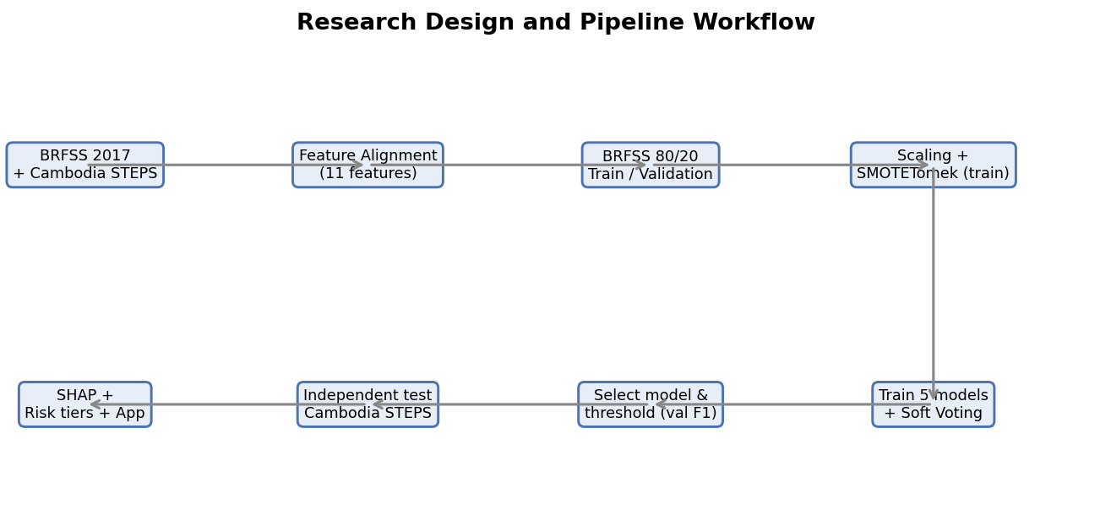
Figure 1: Research design and pipeline workflow, from data loading and feature alignment to training, ensemble selection, threshold tuning, independent testing, explainability, and the dashboard.

3.2 Tools and Technologies Used
All work was done in Python using common open-source libraries.

3.2.1 Python and Visual Studio Code
Python was used as the main language because it has many machine learning libraries and supports Jupyter notebooks, which keep the work organized and repeatable. Visual Studio Code was used as the editor for the notebooks and the application.

3.2.2 pandas, NumPy, and Matplotlib
Pandas and NumPy were used to load, align, clean, and transform the survey data. Matplotlib was used to draw the figures in this report.

3.2.3 scikit-learn
scikit-learn provided the train/validation split, the StandardScaler, the Logistic Regression and Random Forest models, the VotingClassifier used for the Soft Voting ensemble, the RandomizedSearchCV tuning, and the evaluation metrics (accuracy, precision, recall, F1-score, ROC and AUC, and the confusion matrix).

3.2.4 XGBoost, LightGBM, and CatBoost
XGBoost, LightGBM, and CatBoost are gradient boosting libraries that work well on tabular data. They were used as three of the five candidate models, and they support ways to handle class imbalance. XGBoost was also used later as the tree-based model for the SHAP analysis.

3.2.5 imbalanced-learn (SMOTETomek)
The imbalanced-learn library provided SMOTETomek, which combines SMOTE oversampling with Tomek-links cleaning. It was applied only to the training data.

3.2.6 SHAP
The SHAP library was used to explain the model. Its tree explainer computes feature contributions for tree-based models efficiently, for both overall and patient-level explanations.

3.2.7 Streamlit and the Gemini API
The pipeline was deployed as a web application using Streamlit, which shows each prediction as a patient dashboard. The Google Gemini API was used to turn the model explanation into simple lifestyle advice, with a fixed fallback message when the API is not available, so the tool still works offline.

3.3 Data Sources

3.3.1 BRFSS 2017 (Training and Validation)
The BRFSS is a large yearly health survey carried out by the United States CDC. This study uses a cleaned binary version of the 2017 survey with 275,746 records, of which 16.00% are labelled as having diabetes. Its large size and many risk-factor variables make it a good source for training.

3.3.2 Cambodia STEPS (Independent Test)
The WHO STEPS survey is a standard method used in many countries to measure non-communicable disease risk factors. In this study, the Cambodia STEPS dataset was used as the independent external test set. After data preprocessing, target preparation, missing-value handling, and alignment with the BRFSS feature schema, 873 usable records remained for the final experiment. Among these records, 751 were labelled as non-diabetes, and 122 were labelled as diabetes, giving a diabetes rate of 13.98%. This dataset was not used during training, validation, model selection, threshold tuning, scaling, or resampling. It was used only once for final independent testing.

3.4 Data Preparation and Feature Alignment
Because the two surveys were designed separately, their variables do not match exactly. The main preparation task was to align them into a shared set of risk factors that are present in both surveys, low-cost and non-invasive, and make clinical sense. Eleven common features remained after this step, grouped into three categories, as shown in Table 1. The target variable is Diabetes_binary, which is 1 for diabetes and 0 for no diabetes.
Group | Aligned Features
Demographic | Sex, Age, Education
Health Status | HighBP (high blood pressure), HighChol (high cholesterol), BMI
Lifestyle | Smoker, PhysActivity, Fruits, Veggies, HvyAlcoholConsump
Table 1: Aligned feature set common to BRFSS and STEPS (11 features).
Two alignment notes are important. First, age is recorded as a group from 1 to 13 in BRFSS but in actual years in STEPS, so the STEPS ages were converted into the matching BRFSS age groups. Second, income, which is in BRFSS, was dropped because it is not consistently available in STEPS. Keeping only features with a clear match in both surveys makes the transfer fair. Basic cleaning of missing values and consistent encoding was also applied so that the feature columns mean the same thing in both datasets.

3.5 Feature Engineering and Imbalance Handling

3.5.1 Standardisation
The features are on different scales, for example BMI compared with a yes/no smoking value. A StandardScaler was fit on the BRFSS training data to give each feature zero mean and unit variance, and the same scaler was then applied to the BRFSS validation set and the Cambodia STEPS test set. Fitting the scaler only on the training data prevents information from the validation or test data from leaking into the model.

3.5.2 SMOTETomek and Data Leakage
Because people with diabetes are the minority, the training data are imbalanced. SMOTETomek was used to fix this. SMOTE creates new synthetic minority examples by interpolating between real minority points, and the Tomek-links step removes pairs of opposite-class points that sit on the border, which cleans up overlapping cases.
SMOTETomek was applied only to the training set. The validation set and the Cambodia STEPS test set were kept as real, untouched data. This is important because it avoids data leakage: if synthetic data were mixed into validation or test, the results would look better than they really are and would not reflect performance on real people. By balancing only the training data, the reported validation and test numbers come from genuine cases.

3.6 Models Used
Five models were trained on the balanced BRFSS 2017 training data. The four tree-based and boosting models were tuned with RandomizedSearchCV using three-fold cross-validation and F1-score.

3.6.1 Logistic Regression
Logistic Regression is a linear model for binary classification. It is fast and easy to explain and is used here as a baseline. It was set with balanced class weights.

3.6.2 Random Forest
Random Forest is a group of decision trees trained on random samples of the data, whose results are averaged. It captures non-linear patterns and reduces overfitting compared with a single tree.

3.6.3 XGBoost
XGBoost builds trees one after another, where each new tree corrects the errors of the previous ones. It is a strong method for tabular data and can handle imbalance through weighting.

3.6.4 LightGBM
LightGBM is another gradient boosting method that grows trees leaf-wise and uses histogram-based splits, which makes it fast and memory-efficient on large datasets.

3.6.5 CatBoost
CatBoost is a gradient boosting method that is robust and works well with default settings. It was one of the three models chosen for the final ensemble.

3.7 Soft Voting Ensemble
Instead of trusting one model, the pipeline combines the strongest models. After all five models were checked on the validation set, the three best by validation F1-score, which were XGBoost, Logistic Regression, and CatBoost, were combined into a Soft Voting ensemble. Soft Voting works by averaging the predicted diabetes probabilities from the three models. The averaged probability is then compared with the chosen threshold to decide the final class. Soft Voting is useful because it balances the strengths of the different models and usually gives more stable predictions than any single model on its own.

3.8 Threshold Tuning
A model gives a probability, which must be turned into a yes/no decision using a threshold. The default of 0.50 is often not the best choice for imbalanced data. The selection rule used here is to choose the model-and-threshold pair with the highest validation F1-score among those where diabetes recall is at least 70%. This keeps recall high, which is the priority for screening, while still keeping a reasonable balance with precision. Using this rule, the Soft Voting ensemble with a threshold of 0.43 was selected as the final model.

3.9 Evaluation Metrics
Because accuracy can be misleading on imbalanced data, several metrics were used, all based on the confusion matrix.

3.9.1 Confusion Matrix
The confusion matrix shows four values: true positives (diabetes correctly found), true negatives (no diabetes correctly cleared), false positives (no diabetes wrongly flagged, a Type I error), and false negatives (diabetes wrongly cleared, a Type II error). In screening, false negatives are the most harmful, which is why recall is the priority.
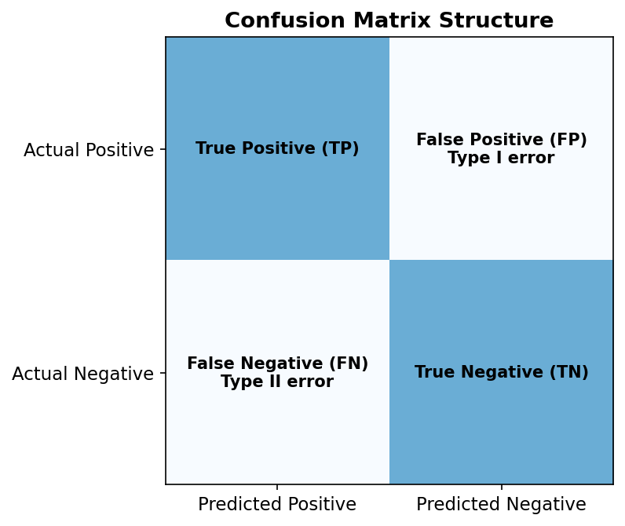
Figure 2: The structure of a confusion matrix, showing true positives, true negatives, false positives, and false negatives.

3.9.2 Accuracy, Precision, Recall, and F1-Score
Accuracy is the share of all predictions that are correct. Precision is the share of flagged people who really have diabetes. Recall is the share of real diabetes cases that the model finds, and it is the main clinical priority here. F1-score is the harmonic mean of precision and recall and balances the two, and it is the main metric used for model selection.

3.9.3 ROC Curve and AUC
The ROC curve plots the true positive rate against the false positive rate as the threshold changes, and the AUC (Area Under the Curve) summarises how well the model separates the two classes across all thresholds. An AUC of 1.0 is perfect and 0.5 is random guessing.
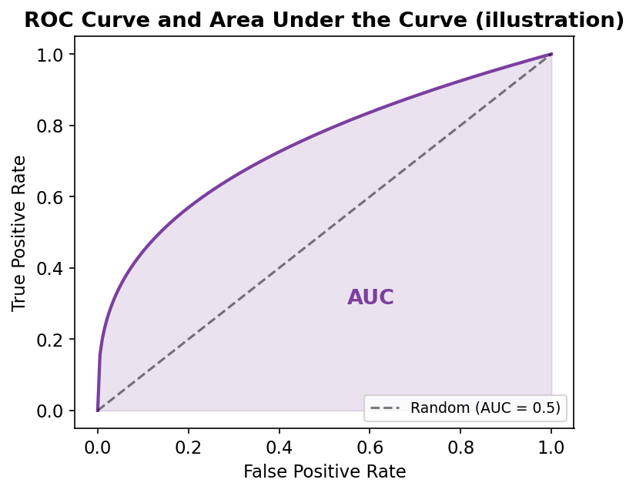
Figure 3: Illustration of an ROC curve and the area under the curve (AUC).

3.10 Explainability Method
Explainability is treated as part of the method, not an extra step. After the final model is selected, SHAP is used on the Cambodia STEPS test set. SHAP gives each feature a value showing how much it increased or decreased the predicted risk, for each person. The absolute SHAP values can be averaged over all patients to give an overall importance ranking, while the values for one patient explain a single prediction.
One point must be made clearly. The final model is a Soft Voting ensemble, so a tree-based SHAP explainer cannot explain the full ensemble exactly. For this reason, XGBoost was used as a tree-based proxy model for SHAP. This choice is reasonable because XGBoost was the strongest individual tree-based model by validation F1-score, it is one of the three models inside the Soft Voting ensemble, and TreeSHAP is efficient and well suited to tree-based models. The SHAP results therefore explain the strongest tree-based part of the ensemble and help us understand the model’s behaviour, but they are not a perfect explanation of the full Soft Voting model.
Finally, the predicted probabilities are grouped into three risk tiers, Low, Moderate, and High, to make the result easier to read in the dashboard. The meaning of these tiers is explained carefully in Section 4.7.

CHAPTER 4
RESULTS

4.1 Experimental Setup
All experiments were run on a personal laptop using the Python tools described in Chapter 3, inside Jupyter notebooks. A fixed random seed of 42 was used for the data split, the resampling, the model setup, and the hyperparameter search, so that the whole pipeline can be reproduced. Hyperparameters were tuned with RandomizedSearchCV using three-fold cross-validation and F1-score.

4.2 Data Distribution
The two surveys differ in size and slightly in diabetes rate. BRFSS 2017 has 275,746 records with a 16.00% diabetes rate, while Cambodia STEPS has 873 usable records after preprocessing and feature alignment, with a 13.98% diabetes rate. Figure 4 compares the two class distributions.
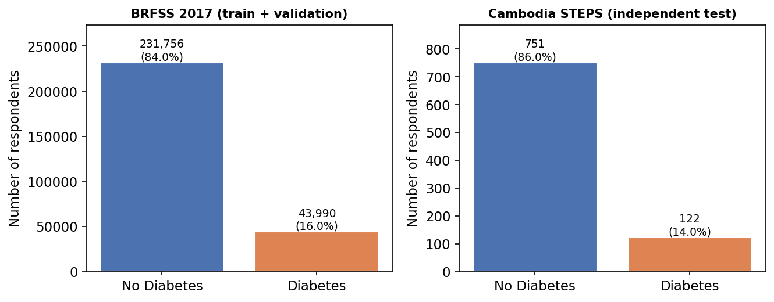
Figure 4: Class distribution of BRFSS 2017 (training source) and Cambodia STEPS (independent test).
The figure shows that both datasets are imbalanced, with far more non-diabetes cases than diabetes cases. The diabetes rate is close in the two experimental datasets (16.0% versus 13.98%), but the BRFSS dataset is much larger, which is why it is used for training.

4.3 Data Splits
The BRFSS 2017 data were split into 80% for training and 20% for validation using stratified sampling, so the diabetes rate stays the same in both parts. The whole Cambodia STEPS dataset was kept as the test set. Table 2 and Figure 5 show the sizes and class balance of each split.

Split | Total Records | No Diabetes | Diabetes | Diabetes Rate
Train — BRFSS 2017 (80%) | 220,596 | 185,404 | 35,192 | 15.95%
Validation — BRFSS 2017 (20%) | 55,150 | 46,352 | 8,798 | 15.95%
Test — Cambodia STEPS | 873 | 751 | 122 | 13.98%
Table 2: Class distribution per data split. Cambodia STEPS contains 873 usable records after preprocessing and feature alignment and is used only for the final test.
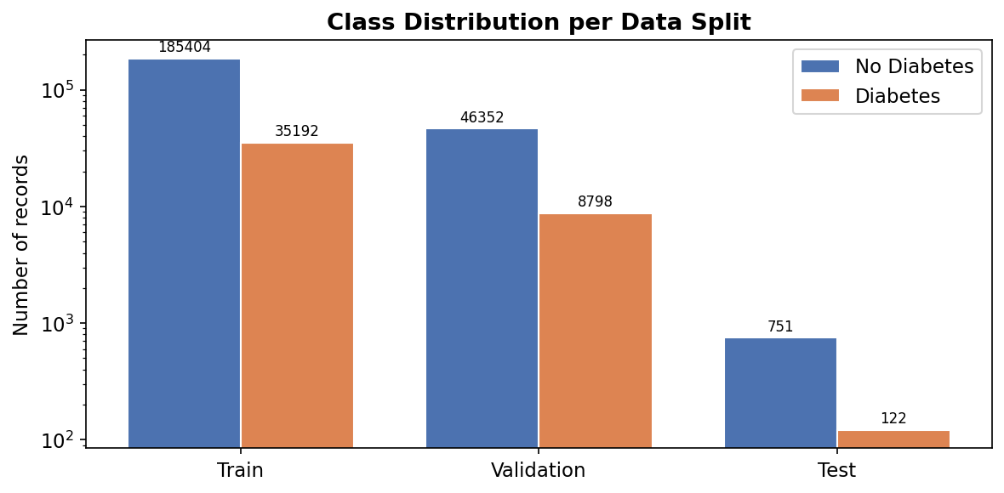
Figure 5: Class distribution across the training, validation, and test splits (log scale, because BRFSS is much larger than STEPS).
Table 2 confirms that the training and validation sets keep almost the same diabetes rate (about 16%), which is the effect of stratified splitting. The Cambodia STEPS test set is much smaller and comes from a different population, which is the main challenge of this study.

4.4 Class Balancing with SMOTETomek
SMOTETomek was applied to the training set only, to balance the two classes before training. Table 3 and Figure 6 show the class counts before and after balancing.
Training Set | No Diabetes | Diabetes
Before SMOTETomek | 185,404 | 35,192
After SMOTETomek | 182,354 | 182,354
Table 3: Training-set class counts before and after SMOTETomek (validation and test untouched).
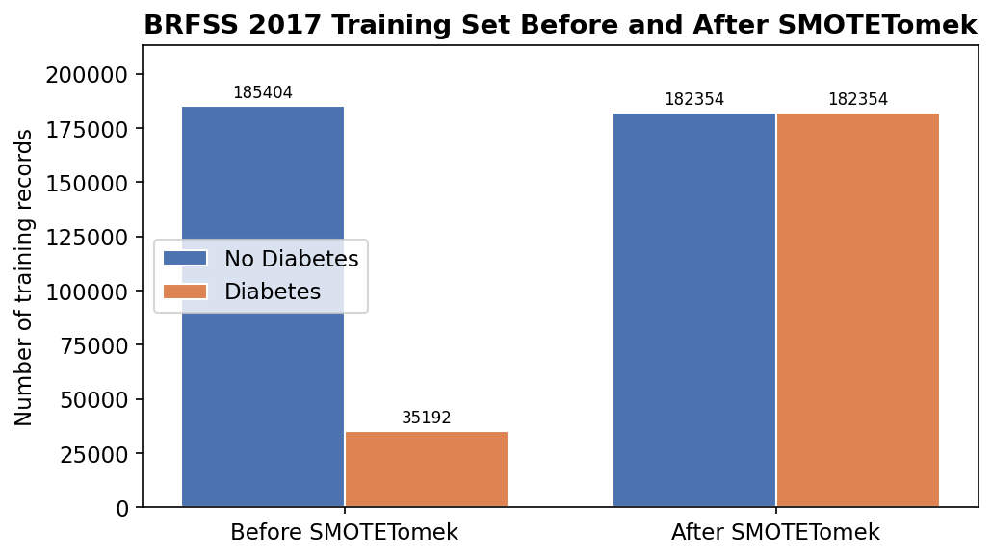
Figure 6: BRFSS 2017 training set before and after SMOTETomek balancing.
After SMOTETomek, the two classes in the training set are equal, with 182,354 records each. This helps the models learn the minority diabetes class better. The validation and test sets were not changed, so the results reported later come from real cases and are not affected by synthetic data.

4.5 Validation Results of Individual Models
The five models were checked on the BRFSS 2017 validation set using a default threshold of 0.50. Table 4 reports accuracy, precision, recall, and F1-score for each model, and Figure 7 shows the same results as a bar chart.
Model | Accuracy | Precision | Recall | F1-score
XGBoost | 77.45% | 37.07% | 59.24% | 45.60%
Logistic Regression | 70.44% | 31.79% | 74.45% | 44.55%
CatBoost | 80.08% | 40.04% | 49.99% | 44.46%
Random Forest | 78.50% | 35.48% | 42.49% | 38.67%
LightGBM | 80.41% | 38.49% | 38.12% | 38.31%
Table 4: Individual model performance on the BRFSS 2017 validation set (threshold 0.50).
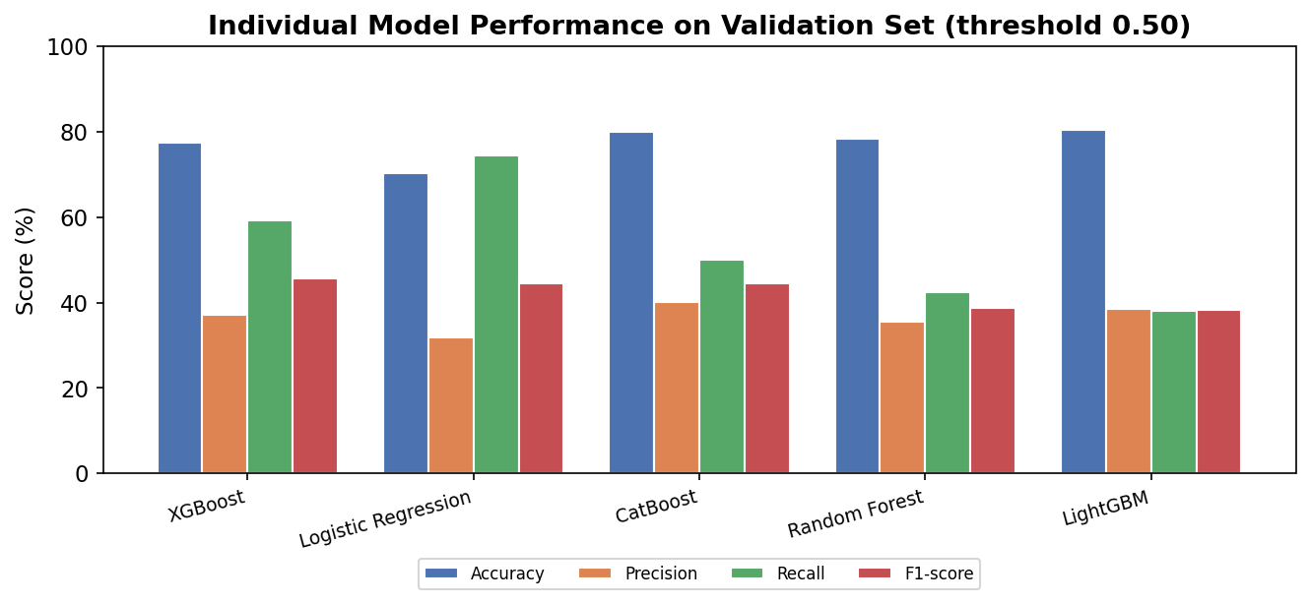
Figure 7: Comparison of the five models on the validation set (threshold 0.50).
The results show a trade-off between recall and precision. Logistic Regression has the highest recall (74.45%) but lower precision, while LightGBM and CatBoost have higher accuracy but lower recall. XGBoost gives the best F1-score (45.60%), with a good balance between recall and precision. Based on validation F1-score, the three best models are XGBoost, Logistic Regression, and CatBoost, which were chosen for the Soft Voting ensemble. The neural network was not used; the final design is based on these tree-based and linear models combined by Soft Voting.

4.6 Final Model and Threshold Selection
The three best models were combined into a Soft Voting ensemble. The final model and threshold were chosen using the rule of highest validation F1-score among options where diabetes recall is at least 70%. This rule selected the Soft Voting ensemble with a threshold of 0.43. Table 5 shows the validation results of the selected model.
Metric | Soft Voting ensemble (Validation, threshold 0.43)
Recall (clinical priority) | 70.46%
F1-score (selection metric) | 45.15%
Accuracy | 72.69%
Precision | 33.22%
Table 5: Validation performance of the selected Soft Voting ensemble at threshold 0.43.
At threshold 0.43, the Soft Voting ensemble reaches a validation recall of 70.46%, which meets the recall requirement, with an F1-score of 45.15%. The accuracy is 72.69% and the precision is 33.22%. The lower threshold (0.43 instead of 0.50) makes the model flag more people as at risk, which raises recall at the cost of precision. This is the correct trade-off for a screening tool.
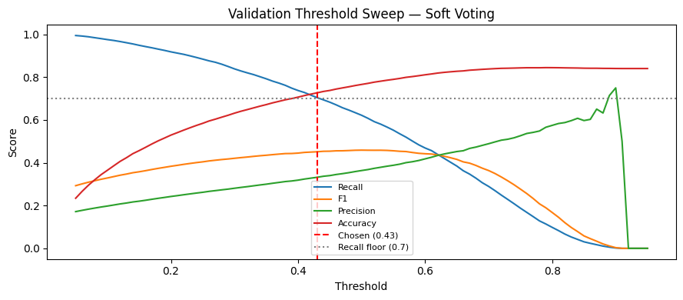
Figure 8: Threshold tuning result on the validation set, showing how recall, precision, F1-score, and accuracy change with the threshold, with the chosen threshold of 0.43 marked.

4.7 Risk Tiers and the Classification Threshold
It is important to separate two different things: the classification threshold and the risk tiers. The classification threshold is the value used to make the yes/no decision. In this study the final threshold is 0.43. If the predicted probability is 0.43 or higher, the person is classified as diabetes risk; if it is below 0.43, the person is classified as no diabetes risk.
The risk tiers are different. They are only a way to communicate the probability level in the dashboard, so the result is easier to understand. The tiers are based on the predicted probabilities from the Soft Voting model on Cambodia STEPS, using these ranges: Low risk is a predicted probability below 30%, Moderate risk is from 30% up to below 70%, and High risk is 70% or above.
These tiers are model-based communication categories. They are not official medical diagnostic cut-offs and should not be presented as clinically validated thresholds. They simply help a reader see whether a predicted probability is low, medium, or high. Table 6 and Figure 9 show how the Cambodia STEPS respondents fall into the three tiers.
Risk Tier | Predicted Probability | STEPS Respondents
Low | below 30% | 299
Moderate | 30% to below 70% | 401
High | 70% or above | 173
Table 6: Risk-tier distribution of the Cambodia STEPS respondents under the Soft Voting model.
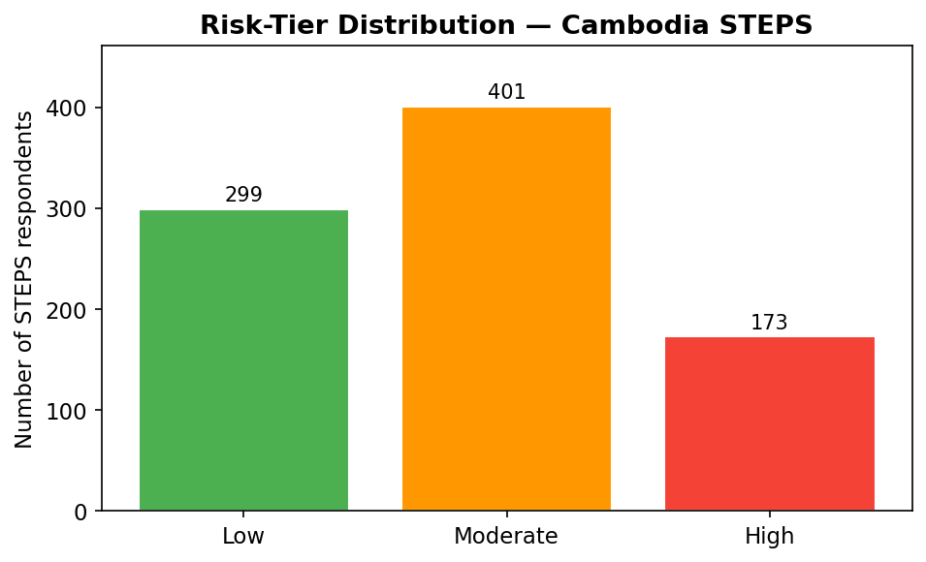
Figure 9: Risk-tier distribution for the Cambodia STEPS test set.
Most respondents fall into the Low and Moderate tiers, with 173 in the High tier. These tiers are only for communication and interpretation; the actual classification still uses the 0.43 threshold described above.

4.8 Independent Test on Cambodia STEPS
The selected Soft Voting model and the 0.43 threshold were then applied, for the first time, to the Cambodia STEPS test set. This data had no part in training, validation, or selection, so it gives an honest measure of how the model transfers to a new population. Table 7 reports the results.
Metric | Cambodia STEPS (independent test)
Recall (clinical priority) | 76.23%
F1-score | 32.40%
Accuracy | 55.56%
Precision | 20.58%
Table 7: Independent test results on Cambodia STEPS (Soft Voting ensemble, threshold 0.43).
The most important result is recall. At 76.23%, the model correctly found most of the real diabetes cases in a population it had never seen, which is what a screening tool needs to do. At the same time, accuracy (55.56%) and precision (20.58%) were lower than on validation, and the F1-score dropped to 32.40%. In simple terms, the model flags many people to make sure it does not miss real cases, but this also produces many false alarms when it is used on a different population.
Figure 10 shows the confusion matrix on Cambodia STEPS. Out of 122 real diabetes cases, the model correctly found 93 and missed 29. Out of 751 non-diabetes cases, it correctly cleared 392 but wrongly flagged 359. This matches the pattern of high recall and low precision.
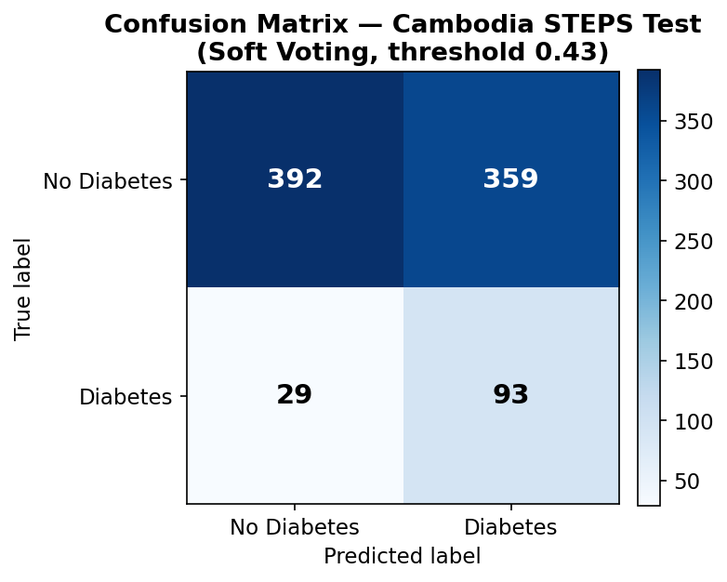
Figure 10: Confusion matrix on the Cambodia STEPS test set (Soft Voting, threshold 0.43).

4.9 Validation vs Test Comparison
Table 8 and Figure 11 compare the validation and test results of the Soft Voting model side by side, which shows the cross-population gap clearly.
Metric | Validation (BRFSS 2017) | Test (Cambodia STEPS)
Recall | 70.46% | 76.23%
F1-score | 45.15% | 32.40%
Accuracy | 72.69% | 55.56%
Precision | 33.22% | 20.58%
Table 8: Validation versus independent-test results for the Soft Voting ensemble.
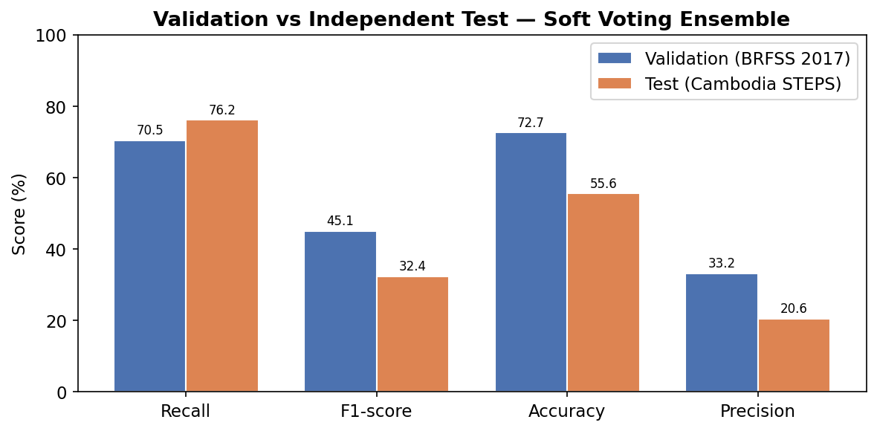
Figure 11: Validation versus Cambodia STEPS test results for the Soft Voting ensemble.
Recall actually went up slightly from validation (70.46%) to test (76.23%), because the low threshold flags many cases. But accuracy and precision dropped on the Cambodia data. This is the effect of cross-population domain shift: the link between the risk factors and diabetes in Cambodia is not the same as the one the model learned from United States data. This is an honest result and is expected when transferring a model between very different populations.

4.10 Explainability Results
SHAP was used on the Cambodia STEPS predictions, with XGBoost as the tree-based proxy model explained in Section 3.10. Figure 12 shows the overall feature importance, based on the average absolute SHAP values, and Figure 13 shows a local explanation for one patient. In line with medical knowledge and earlier studies, the strongest factors were body mass index, high blood pressure, high cholesterol, and age, while lifestyle factors such as physical activity and fruit and vegetable intake tended to lower the predicted risk.
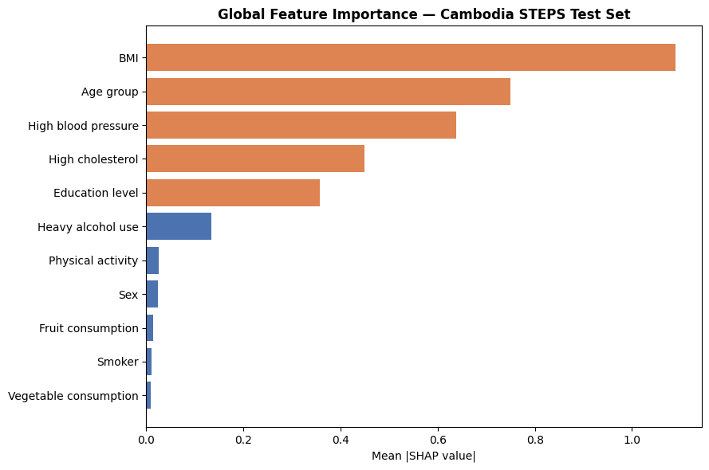
Figure 12: SHAP global feature importance (mean absolute SHAP value) on the Cambodia STEPS test set, using XGBoost as the tree-based proxy model.
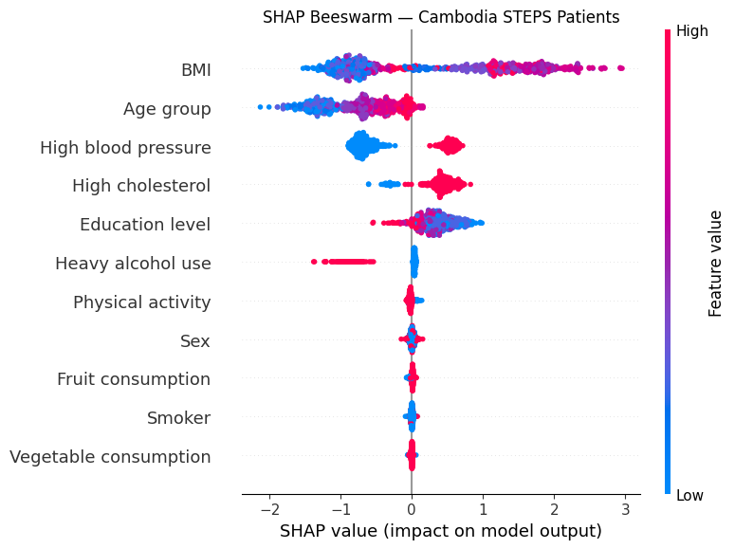
Figure 13: SHAP local explanation for a single Cambodia STEPS patient, showing which features increased or decreased the predicted risk.
These explanations are useful in two ways. Overall, they show that the model relies on sensible health factors and not on strange patterns, which helps build trust. For a single patient, they give a short and clear reason for the prediction, which is the basis of the dashboard. As noted before, these SHAP results explain the strongest tree-based part of the ensemble, not the full Soft Voting model exactly.
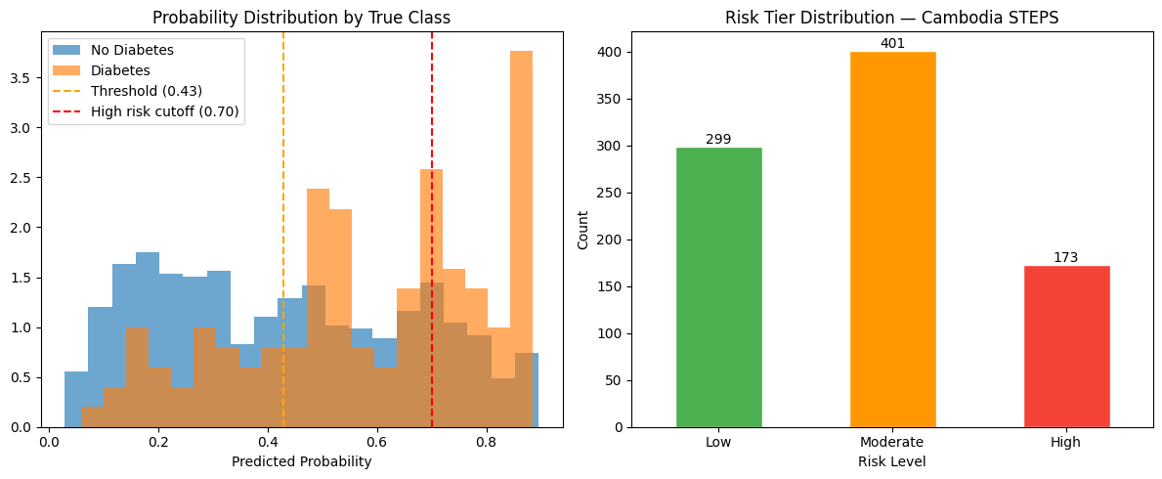Figure 14: Distribution of predicted probabilities on Cambodia STEPS, separated by true class, with the 30% and 70% tier cut-offs marked.

4.11 Patient Dashboard and Actionable Insights
The final model is shown to the user through a Streamlit dashboard. For each person, the dashboard shows the predicted probability and risk tier, the main SHAP reasons colored by whether they raise or lower risk, the contribution of the demographic, health-status, and lifestyle groups, and simple lifestyle advice generated through the Gemini API with a safe offline fallback. The application can also accept a CSV file to screen many people at once. This turns a single number into an explanation and a set of actionable insights that a non-expert can understand.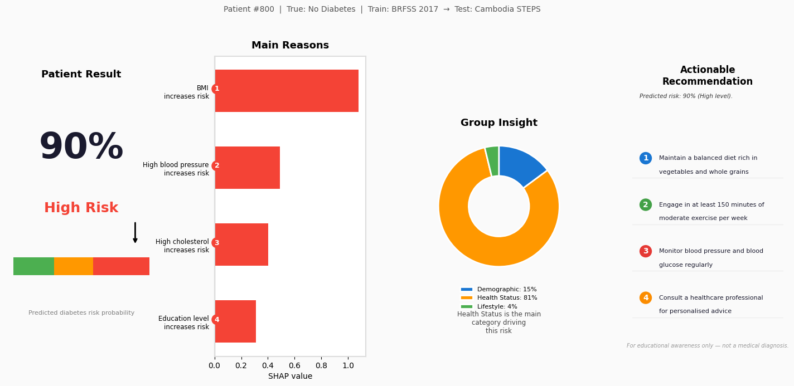
Figure 15: Patient dashboard from the deployed application, showing the risk gauge, the main SHAP reasons, the group contributions, and the lifestyle advice.
It is important to repeat that the dashboard is a screening support tool, not a medical diagnosis system. A High risk result is a reason to do a proper medical test, not a confirmed diagnosis.

CHAPTER 5
DISCUSSION

5.1 Overview
This chapter explains what the results mean for diabetes screening in Cambodia. It looks at how well the models worked, the cross-population gap, the value of explainability and the dashboard, and the main challenges of the study.

5.2 Effectiveness of the Models
On the validation data, the approach worked as expected. The tree-based and boosting models performed well, and the Soft Voting ensemble combined the strengths of XGBoost, Logistic Regression, and CatBoost. Choosing the model and threshold by validation F1-score with a recall requirement made sure the final model fits the needs of screening rather than just chasing accuracy.
The choice to focus on recall was the most important design decision. If the project had focused on accuracy, it could have reported a higher accuracy by leaning toward the majority “no diabetes” class, but the tool would then miss many real cases. By keeping recall high, the model is more careful, which is the safer choice for screening. The cost is lower precision and more false alarms, but a false alarm only leads to an extra test, while a missed case can lead to untreated disease.

5.3 The Cross-Population Gap
The clearest finding is the gap between validation and test. On the BRFSS validation data the model worked reasonably, but when used on Cambodia STEPS its accuracy and precision dropped, even though recall stayed high. This is the effect of domain shift, and it is exactly what single-population studies cannot show, because they test on data similar to the training data.
There are several likely reasons. The link between body mass index and diabetes risk is known to differ between Western and Asian populations, so a value learned on United States data may not fit Cambodia well. Diet, physical activity, and the way survey questions are asked also differ, so even aligned features are not perfectly equal. The eleven common features, while needed for a fair test, also leave out information that a local model could use.
The honest reading is not that the model failed, but that transferring a diabetes model from one population to a very different one is hard. A transferred model like this should be treated as a first-pass screening tool with high recall, whose positive results need local confirmation, and not as a diagnostic system.

5.4 Value of Explainability and the Dashboard
Even with its limits as a predictor, the system has real value because it is explainable and deployed. The SHAP analysis showed that the model uses sensible health factors such as body mass index, blood pressure, cholesterol, and age, which is important for trust. The patient-level explanations turn a probability into a short reason, and the lifestyle advice turns that reason into action. The dashboard puts all of this in a form that a non-expert can use, and the batch mode supports screening many people. In a setting where trust and clarity matter as much as raw accuracy, these are important features and not just extras. The honesty of using XGBoost as a proxy for SHAP, rather than claiming a perfect explanation of the ensemble, also keeps the interpretation realistic.

5.5 Challenges and Findings
Several challenges shaped this work. The main one was data: the lack of a large local labelled dataset is the reason transfer learning was needed, and the small size of the Cambodia STEPS test set, with 873 usable records after preprocessing and feature alignment, limits how precise the external test results can be. Aligning two different surveys into a fair common set needed careful choices, such as the age-group mapping and dropping income. Class imbalance needed careful handling with SMOTETomek and threshold tuning, applied only to the training data to avoid leakage. Balancing performance with explainability and ease of use was also a constant concern.
The main findings are clear. Tree-based and boosting models, combined by Soft Voting, are a good fit for this tabular task. A recall-focused threshold is essential for screening and changes how the model behaves. Cross-population transfer has a real cost that single-population studies hide, and reporting this honestly is more useful than an inflated accuracy claim. And explainability is what makes the tool trustworthy and usable in practice.

CHAPTER 6
CONCLUSION

6.1 Summary of Findings
This study built and tested an explainable machine learning pipeline for diabetes risk screening in Cambodia, using a model trained on the large United States BRFSS 2017 survey and tested once on the independent Cambodia STEPS dataset. Eleven common risk factors were aligned into a shared set; the training data were scaled and balanced with SMOTETomek; five models were trained; and the three best (XGBoost, Logistic Regression, and CatBoost) were combined into a Soft Voting ensemble. The final model and threshold were chosen by validation F1-score while keeping recall at least 70%.
The selected Soft Voting ensemble, at a threshold of 0.43, reached a recall of 76.23% on the Cambodia STEPS test set, finding most of the real diabetes cases in a population it had never seen. Accuracy (55.56%) and precision (20.58%) were lower on the Cambodian data, which honestly reflects the difficulty of cross-population transfer rather than a fault of the method. SHAP, using XGBoost as a proxy, showed that the model relies on sensible health factors and allowed clear patient-level explanations, which were shown together with risk tiers and lifestyle advice in a dashboard.
The contribution of this study is an honest benchmark for cross-population diabetes risk transfer to a low-resource setting, a screening pipeline focused on recall and explainability instead of headline accuracy, and a working, explainable tool that gives actionable insights. The main message is that this kind of transferred, recall-focused screening model can be a useful early-awareness and research tool, but it cannot replace medical diagnosis, and its positive results should always be confirmed by a proper medical test.

6.2 Future Work
Several directions could build on this study. The most important is to collect local labelled Cambodian data. Even a moderate, confirmed dataset would allow the model to be retrained or fine-tuned for the local population, which the results suggest would improve precision and calibration.
• Domain adaptation: apply domain-adaptation or transfer-learning methods, such as fine-tuning on a small local sample, to reduce the cross-population gap.
• Richer features: add more locally useful features that were left out of the common set, such as waist circumference, sedentary time, and more detailed diet information, where they can be collected reliably.
• Calibration: calibrate the predicted probabilities so that the risk tiers better match the true probabilities in the Cambodian population.
• Fairness: check the model for fairness across sex, age, and income groups using the SHAP tools already in place.
• Field testing: test the tool in a real setting with community health workers, and move toward real-time and offline use.
Together, these steps would move the system from an honest research benchmark toward a locally validated and fair screening support tool that could help with early diabetes awareness in Cambodia.

REFERENCES
[1] Z. Xie, O. Nikolayeva, J. Luo, and D. Li, “Building risk prediction models for type 2 diabetes using machine learning techniques,” Preventing Chronic Disease, vol. 16, p. E130, 2019. doi: 10.5888/pcd16.190109.
[2] P. B. Khokhar, V. Pentangelo, F. Palomba, and C. Gravino, “Towards transparent and accurate diabetes prediction using machine learning and explainable artificial intelligence,” arXiv preprint arXiv:2501.18071, 2025. doi: 10.48550/arXiv.2501.18071.
[3] P. B. Khokhar, C. Gravino, and F. Palomba, “Advances in artificial intelligence for diabetes prediction: Insights from a systematic literature review,” Artificial Intelligence in Medicine, vol. 164, p. 103132, 2025. doi: 10.1016/j.artmed.2025.103132.
[4] M. Li, A. Tan, L. Song, X. Qiu, L. Zhou, and Z. Wen, “Performance of diabetes risk prediction models: A systematic review and meta-analysis,” Endocrine Connections, vol. 14, no. 11, p. e250353, 2025.
[5] Centers for Disease Control and Prevention, “2017 BRFSS survey data and documentation,” 2017.
[6] World Health Organization, “STEPwise approach to NCD risk factor surveillance (STEPS),” World Health Organization.
[7] T. Chen and C. Guestrin, “XGBoost: A scalable tree boosting system,” in Proceedings of the 22nd ACM SIGKDD International Conference on Knowledge Discovery and Data Mining, 2016, pp. 785–794. doi: 10.1145/2939672.2939785.
[8] G. Ke et al., “LightGBM: A highly efficient gradient boosting decision tree,” Advances in Neural Information Processing Systems, vol. 30, 2017.
[9] L. Prokhorenkova, G. Gusev, A. Vorobev, A. V. Dorogush, and A. Gulin, “CatBoost: Unbiased boosting with categorical features,” Advances in Neural Information Processing Systems, vol. 31, 2018.
[10] L. Breiman, “Random forests,” Machine Learning, vol. 45, no. 1, pp. 5–32, 2001. doi: 10.1023/A:1010933404324.
[11] S. M. Lundberg and S.-I. Lee, “A unified approach to interpreting model predictions,” Advances in Neural Information Processing Systems, vol. 30, pp. 4765–4774, 2017.
[12] N. V. Chawla, K. W. Bowyer, L. O. Hall, and W. P. Kegelmeyer, “SMOTE: Synthetic minority over-sampling technique,” Journal of Artificial Intelligence Research, vol. 16, pp. 321–357, 2002.
[13] F. Pedregosa et al., “Scikit-learn: Machine learning in Python,” Journal of Machine Learning Research, vol. 12, pp. 2825–2830, 2011.
[14] G. Lemaître, F. Nogueira, and C. K. Aridas, “Imbalanced-learn: A Python toolbox to tackle the curse of imbalanced datasets in machine learning,” Journal of Machine Learning Research, vol. 18, no. 17, pp. 1–5, 2017.
[15] International Diabetes Federation, IDF Diabetes Atlas, 10th ed. Brussels, Belgium: International Diabetes Federation, 2021.

APPENDICES

Appendix A: Deployed Application
The diabetes risk-screening prototype was implemented using Streamlit. The application allows a user to enter individual health information or upload a CSV file for batch prediction. The dashboard displays the predicted diabetes risk probability, risk tier, main SHAP-based explanation factors, grouped feature contributions, and lifestyle recommendations. A screenshot of the application interface is included in Figure 15.

Appendix B: Source Code and Notebooks
The complete source code includes the final training notebook train_2017_v2.ipynb, the data-preparation files, saved model files, scaler file, threshold file, feature-name file, and the Streamlit application file app.py. These files are used to reproduce the final experiment and run the deployed prototype.

Appendix C: Reproducibility
All experiments used a fixed random seed of 42. The BRFSS 2017 dataset was split into 80% training and 20% validation using stratified sampling. SMOTETomek was applied only to the training set. The Cambodia STEPS dataset was used only once as the independent test set. The final Soft Voting ensemble, scaler, selected threshold of 0.43, and aligned feature list were saved and loaded directly by the application, ensuring that the model used in the dashboard matches the model evaluated in this report.

